The JFK Files
RULES: USPSA Handgun Competition Rules COURSE DESIGNER: Kirt McKenna
START POSITION: Standing inside of the shooting area, facing downrange, with toes touching X’s. Handgun is loaded and holstered with wrists below belt.
PCC START: Same as handgun. Carbine is loaded with stock touching belt.
STAGE PROCEDURE  On start signal, engage targets from within the shooting area. | SCORING  SCORING: Comstock, 20 rounds, 10 points  TARGETS: 10 USPSA  SCORED HITS: 2 Best per USPSA  START-STOP: Audible - Last shot  PENALTIES: Per current USPSA rulebook

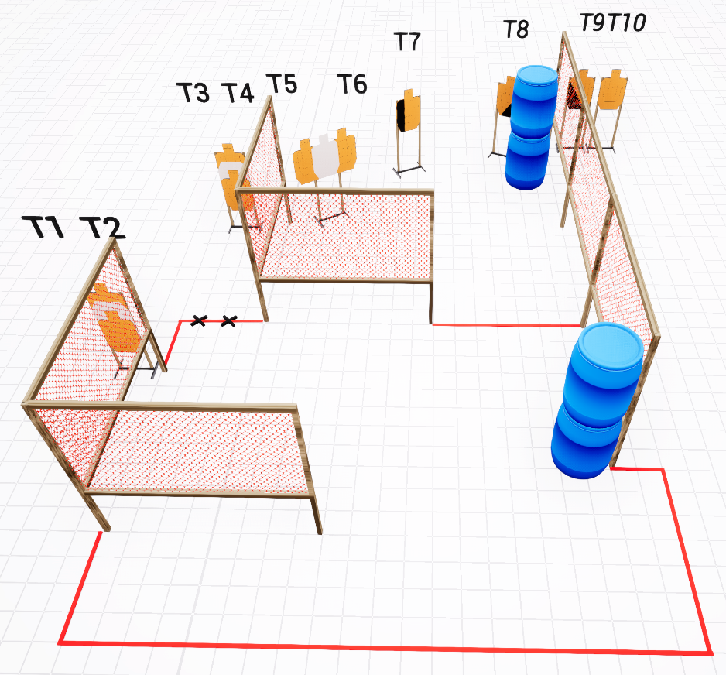

SETUP NOTES: Reduce visibility of T5-T8 from the position intended to engage T9-T10. |  | RO NOTES:

